### The West Region

The West Region is famous for ***

## Nine States make up the West:

|  |  |  |
| --- | --- | --- |
|  |  |  |
|  |  |  |
|  |  |  |

## Major Cities:

|  |  |  |
| --- | --- | --- |
|  |  |  |
|  |  |  |

### The Southeast Region

The Southeast Region is famous for its ***

## Twelve States make up the Southeast:

|  |  |  |
| --- | --- | --- |
|  |  |  |
|  |  |  |
|  |  |  |
|  |  |  |

## Major Cities:

|  |  |  |
| --- | --- | --- |
|  |  |  |
|  |  |  |

Your Name

Mrs. ****

4th Grade

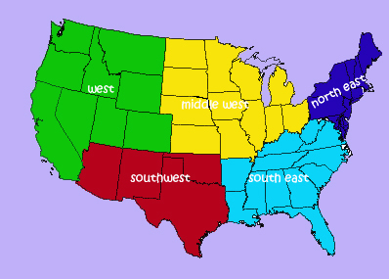

# Regions of the United States

Explore from “Sea to Shining Sea”

### The MidWest Region

The Midwest Region is famous for its prairies, forests, farming, industry and shipping in the rivers and Great Lakes.

## Twelve States make up the MidWest:

|  |  |  |
| --- | --- | --- |
| Michigan | Ohio | North Dakota |
| Iowa | Illinois | Indiana |
| South Dakota | Kansas | Missouri |
| Nebraska | Wisconsin | Minnesota |

## Major Cities:

|  |  |  |
| --- | --- | --- |
| Detroit | Cincinnati | Chicago |
| St. Louis | Duluth | Milwaukee |

### The NorthEast Region

The Northwest Region is famous for ***

## Eleven States make up the Northeast:

|  |  |  |
| --- | --- | --- |
|  |  |  |
|  |  |  |
|  |  |  |
|  |  |  |

## Major Cities:

|  |  |  |
| --- | --- | --- |
|  |  |  |
|  |  |  |

### The Southwest Region

The Southwest Region is famous for ***

## Four States make up the Southwest:

|  |  |
| --- | --- |
|  |  |
|  |  |

## Major Cities:

|  |  |  |
| --- | --- | --- |
|  |  |  |
|  |  |  |

For information on open positions or to submit your resume, please visit our Web site at: www.lucernepublishing.com