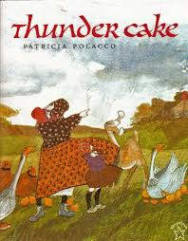
Thunder Cake
Cut and Paste
What ingredients do you need to gather to make thunder cake before the storm arrives? 1…2…3…4…
Copy and paste the pictures into the correct box.

Ctrl + C = Copy Ctrl + V = Paste Ctrl + P = Print
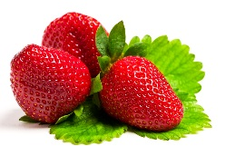 | 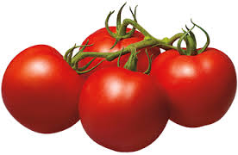 | 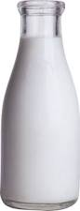
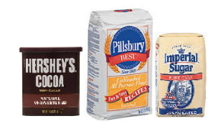 | 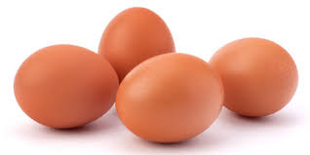

Chocolate, sugar, and flour | Eggs | Milk
Over-ripe tomatoes | Strawberries

