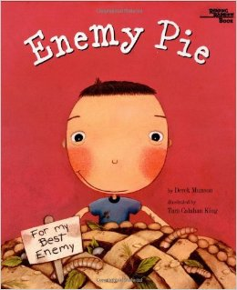
Copy and Paste
Enemy Pie

What kind of horrible, disgusting things would you put into a pie for your enemy?

Copy and paste the pictures into the correct box.
Ctrl + C = Copy Ctrl + V = Paste Ctrl + P = Print
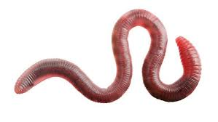 | 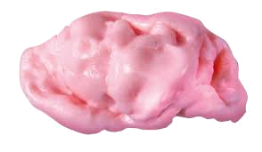 | 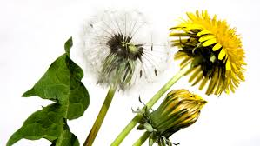
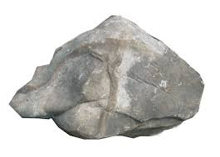 | 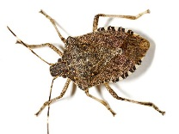 | 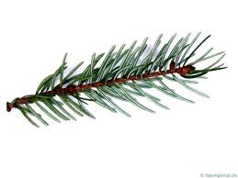

chewed gum
rock
pine needles
weeds
stink bug
worms

