**C:\Users\administrator\AppData\Local\Microsoft\Windows\Temporary Internet Files\Content.IE5\DNSP16OO\MC900437565[1].wmf**

Photo Editing Fun 2.0

**Name:**

**After Editing**

**Before Editing**

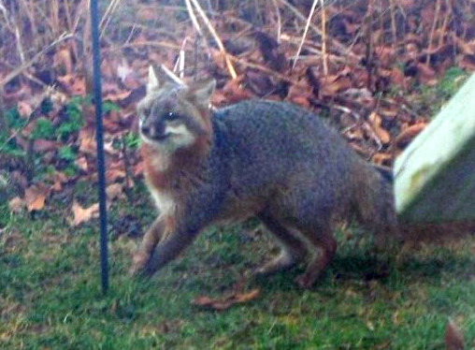

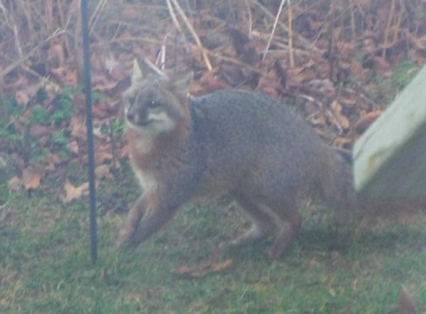

**How *I sharpened* this picture:**

**How I *flipped* this picture:**

**How *I cropped* this picture:**